detailed requirements of the software

Highway CUAHANG -SRS-001

Version 1.0

**Edit History**

|  |  |  |  |  |
| --- | --- | --- | --- | --- |
| **Date** | **Version** | **Description** | **Author** | **Modified by** |
| 1/5 / 202 2 | 1.0 | First version | Group 4 | Group 4 |
| 5/5/2022 2 | 1.0 | Build the basic method | Group 4 | Group 4 |
| 12/5 / 202 2 | 1.0 | Create pages that link together | Group 4 | Group 4 |
| 5/15/2002 2 _ _ | 1.0 |  | Group 4 | Group 4 |

Table of Contents

1. Introduction 5

1.1.Overview 5

1.2 Scope 5

2. Y functional requirements 5

2.1.Feature/Component #1: Login Screen 5

2.1.1: User Interface 5

Screen 1.Login Screen 5

2.1.2 Functional requirements 6

2.2. Feature/Component #2: Sign Up Screen 7

2.2.1 Registration screen 7

Screen2.Registration 7

2.2.2 Functional requirements 8

2.3: Feature/Component #3: Home Screen 8

2.3.1: Home screen 8

Screen 3. Home Screen. 8

2.3.2 Functional requirements 8

2.4: Feature / Component #4: Customer Management 9

2.4.1: Customer management: 9

screen 4.Customer management 9

2.4.2 Functional requirements 10

2.5 Feature/Component #5: Vendor Management 11

2.5.1: Supplier management 11

Screen5.Vendor Management 11

2.5.2 Functional requirements: 11

2.6: Feature / Component # 6: Manage Outbound Merchandise 12

2.6.1: List of goods 12

Screen 6.Display of the list of goods. 12

2.6.2 Functional requirements: 12

2.7 : Feature / Component # 7: Merchandise Creation Screen 14

Merchandise creation screen 14

Screen 7.Merchandise Creation 14

2.7.2 Functional requirements: 14

2.8: Feature/Component #7: Create Invoice 15

2.8.1: Create Invoice 15

2.8.2 Functional requirements: 15

2.9: Feature / Component #7 : Invoice List 16

2.9.1: List of invoices 16

Screen 9.Invoice List 16

# 1. Introduction

## 1.1.Overview

The application allows to manage import and export goods

## 1.2 Scope

* Preview
* Demo version is for display purposes only, not associated with Database
* iOS operating system: IOS 10.4 to 14.6
* iOS Testing Devices: Iphone Xr, Iphone 11 Pro
* Only supports screen orientation in portrait mode

# 2. Y functional requirements

## 2.1.Feature/Component #1: Login Screen

### 2.1.1: User Interface

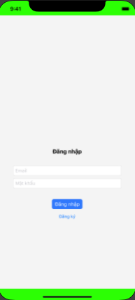

Screen 1.Login Screen

### 2.1.2 Functional requirements

|  |  |  |  |
| --- | --- | --- | --- |
| Item | Description | Work | Respone |
| My system registration screen | The My System Registration screen has 2 buttons:   * Log in * Registration | N / A | N / A |
| Registration | Click the Rigister button to register | when we click the subscribe button  , we are taken to the registration screen | Successful registration screen is displayed |
| Log in | There are 2 text boxes to enter data:   * Email * Password | enter required data | Successfully logged in to the main screen |

## 2.2. Feature/Component #2: Sign Up Screen

### 2.2.1 Registration screen

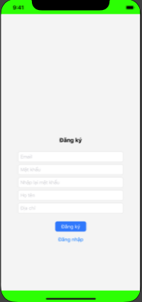

Screen2.Registration

|  |  |  |  |
| --- | --- | --- | --- |
| Item | Description | Work | Respone |
| Register screen | There are 2 buttons and 5 text boxes:   * Email * Password * Enter password * First and last name * Address | N / A | N / A |
| Register screen | Insert information:   * Email * Password * Enter password * First and last name * Address | Display successful login message | The screen shows a successful registration message |

### 2.2.2 Functional requirements

## 2.3: Feature/Component #3: Home Screen

### 2.3.1: Home screen

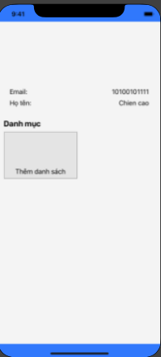

Screen 3. Home Screen.

### 2.3.2 Functional requirements

|  |  |  |  |
| --- | --- | --- | --- |
| Item | Description | Work | Respone |
| Home screen | There are 6 buttons with 6 functions:   * Log out * Customer management * Supplier Management * List of goods * Bill * List of invoices | N / A | N / A |
| Log out | Click logout when the user wants to return to the login page | Click sign out | Back to login screen |
| 5 functions | With the remaining 5 functions:   * Customer management * Supplier Management * List of goods * Bill * List of invoices | Press 1/5 to go to the function the user wants to perform | Bring the interface to be manipulated successfully |

## 2.4: Feature / Component #4: Customer Management

### 2.4.1: Customer management:

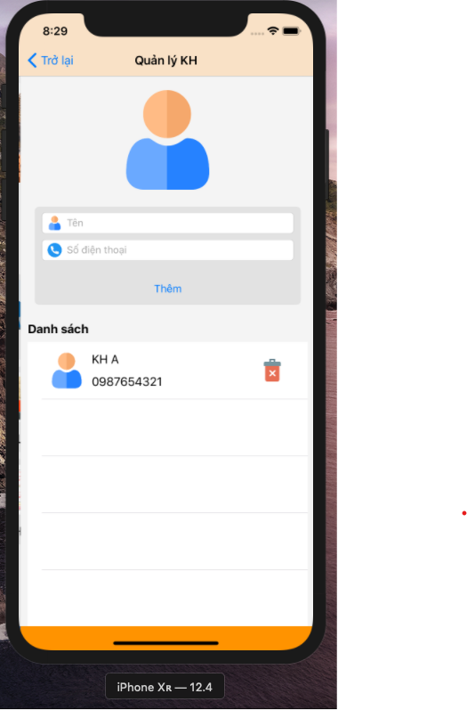

screen 4.Customer management

### 2.4.2 Functional requirements

|  |  |  |  |
| --- | --- | --- | --- |
| Item | Description | Work | Respone |
| Customer screen | There are 3 buttons:   * Backside * Add * Erase | N / A | N / A |
| “Back” buttons | when user press back it will return to home screen | Click Back | Back to home screen successfully |
| “Add” buttons | If the user does not enter the information, an error message will be displayed | Click More | Display a request for information |
| “Add” buttons | Enter all required information | Click More | Add successful customer information |
| “Delete” buttons | When a user wants to delete a customer | Click Delete | Show message whether you want to delete or not |

## 2.5 Feature/Component #5: Vendor Management

### 2.5.1: Supplier management

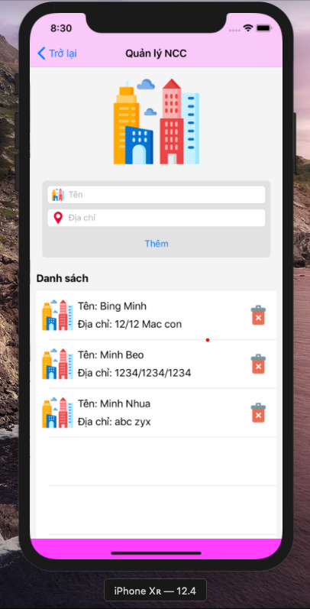

Screen5.Vendor Management

### 2.5.2 Functional requirements:

|  |  |  |  |
| --- | --- | --- | --- |
| Item | Description | Work | Respone |
| **require function** | There are 3 buttons:   * Backside * Add * Erase | N / A | N / A |
| “Back” buttons | when user press back it will return to home screen | Click Back | Back to home screen successfully |
| “Add” buttons | If the user does not enter the information, an error message will be displayed | Click More | Display a request for information |
| “Add” buttons | Enter all required information | Click More | Add successful customer information |
| “Delete” buttons | When a user wants to delete a customer | Click Delete | Show message whether you want to delete or not |

## 2.6: Feature / Component # 6: Manage Outbound Merchandise

### 2.6.1: List of goods

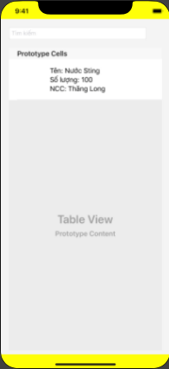

Screen 6.Display of the list of goods.

### 2.6.2 Functional requirements:

|  |  |  |  |
| --- | --- | --- | --- |
| Item | Description | Work | Respone |
| **List of goods** | There are 3 buttons:   * Backside * Add * Erase * Search | N / A | N / A |
| “Back” buttons | when user press back it will return to home screen | Click Back | Back to home screen successfully |
| “Search” buttons | If the user does not enter the information, an error message will be displayed | Click More | Display a request for information |
| “Search” buttons | Enter the information you are looking for | Click More | Display the information you need to successfully search |
| “+” buttons | There is a function to take to the material creation page | Click + | Go to successful component creation page |
| “Delete” buttons | When a user wants to delete a customer | Click Delete | Show message whether you want to delete or not |

## 2.7 : Feature / Component # 7: Merchandise Creation Screen

### Merchandise creation screen

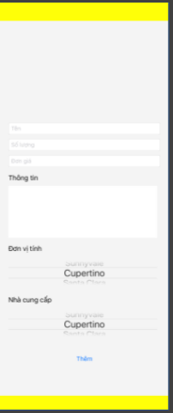

Screen 7.Merchandise Creation

### 2.7.2 Functional requirements:

|  |  |  |  |
| --- | --- | --- | --- |
| Item | Description | Work | Respone |
| **Create materials** | There are 3 buttons:   * Backside * More photos * Add | N / A | N / A |
| “Back” buttons | when user press back it will return to home screen | Click Back | Back to home screen successfully |
| “Add” buttons | If the user does not enter the information, an error message will be displayed | Click More | Display a request for information |
| “Picture” buttons | Can select images in system files | Click Image | Display image input panel |
| “+” buttons | There is a function to take to the material creation page | Click + | Go to successful component creation page |

## 2.8: Feature/Component #7: Create Invoice

### 2.8.1: Create Invoice

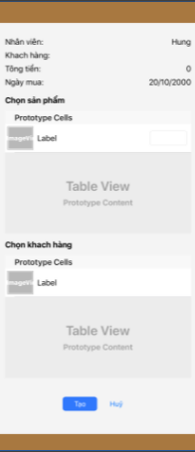

Invoice 8.creation screen

### 2.8.2 Functional requirements:

|  |  |  |  |
| --- | --- | --- | --- |
| Item | Description | Work | Respone |
| **Bill** | There are 3 buttons:   * Backside * Add * Cancel | N / A | N / A |
| “Back” buttons | when user press back it will return to home screen | Click Back | Back to home screen successfully |
| “Add” buttons | If the user does not enter the information, an error message will be displayed | Click More | Display a request for information |
| “Add” buttons | Enter quantity and select customer | Click More | Successfully added invoice |
| “Cancel” buttons | click to cancel order | Click Cancel | display a message that the order has been successfully canceled |

## **2.9: Feature / Component #7** : Invoice **List**

### 2.9.1: List of invoices

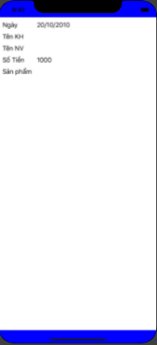

Screen 9.Invoice List

**2.9.2:**

|  |  |  |  |
| --- | --- | --- | --- |
| Item | Description | Work | Respone |
| **List of invoices** | There are buttons:   * Backside | N / A | N / A |
| “Back” buttons | when user press back it will return to home screen | Click Back | Back to home screen successfully |
| List of invoices | User can see invoice added before | N / A | N / A |